Project Plan

Logistics System
for
National Disaster Risk Reduction Management Council

Project Documentation Submitted
To the Faculty of School of
Computer Science and Information Technology
Of
Asia Pacific College

In Partial Fulfillment of the Requirements for the subject
Project Management

MI151

Shaun Ibanez – Project Manager
Krisper Bariuan – Project Documenter
Zian Vertudes – Systems Analyst
Buena Talosig – QA Staff

April 3, 2017

Approval Signatures

Prepared by: Jana Gardon / date |  | Approved by: PANELIST / date
Reviewed by: Johanna Heramia  Lorenzo Tadeo |  | Approved by: PANELIST / date
Noted by: Jacob Catayoc / date |  | Noted by: Rhea Valbuena / date
Remarks by Panelists:

________________________________________________________________
Table of Contents
Project Plan 1
1. Project Overview 1
1.1 Purpose, Scope, and Objectives 1
1.2 Key Schedule Milestone 3
1.3 Main Project Success Criteria 3
1.4 Project Deliverables 4
1.5 Schedule and Budget Summary 5
1.6 References 6
1.7 Definitions and Acronyms 6
2. Project Organization 7
2.1 External Interfaces 7
2.2 Internal Structure 7
2.3 Roles and Responsibilities 8
3. Project Scope / Time / Cost Management Plan 9
3.1 Scope 9
3.1.1 Requirements Traceability Matrix 9
3.1.2 Scope Statement 10
3.1.3 Work Breakdown Structure 1
3.1.3 Work Breakdown Structure Dictionary 2
3.1.4 Gantt Chart 16
3.1.5 Resource Acquisition 18
3.2 Time 19
3.2.1 Activity List 19
3.2.2 Milestone List 30
3.2.3 Schedule Control 30
3.3 Cost 1
3.3.1 Budget Allocation 1
3.3.2 Budget Control 2
4. Project Quality Management Plan 3
4.1 Quality Assurance 3
4.2 Quality Checklist 4
4.3 Quality Control 10
5. Project Human Resource Management Plan 11
5.1 Responsibility Assignment Matrix 11
6. Project Communication Management Plan 15
6.1 Stakeholder Register 15
6.2 Stakeholder Management Strategy 15
6.3 Stakeholder Communication Analysis 16
6.4 Lessons-Learned Report 16
7. Project Risk Management Plan 17
7.1 Top 5 Risks 17
7.2 Risk flowchart 18
8. Project Procurement Management Plan 19
8.1 Procurement Process 19

Project Overview

Purpose, Scope, and Objectives
Purpose
- This project will provide records of data for tracking delivered and stored goods or equipment in different warehouses.
- This project will minimize data corruption or loss by having distributed system and tools that is fault tolerance.
- This project will help the logistics of NDRRMC by locating needed items for a certain number of population during preparation and after disaster.
- This project will efficiently monitor the distribution of items in their respective warehouses.
- This project will help logistics in faster communication and faster transferring of data among different government agencies and systems such as inventory, procurement, law and order, food and non-food, dead and missing, monitoring and camp coordination.
- This project will help lessen corruption in the government since information in database are not shared or cannot be edit and secure.

Scope
- The scope of this project includes defining requirements, designing, developing, testing, deployment and maintenance of product.
- This project will only cover the prepared and response phase of the disaster for NDRRMC
- This project will not include the recovery phase of the disaster.

Objectives
- To provide a logistics system that has can store large amount of data and integrates the following modules:
  - Management of User – handles the hierarchy of users.
  - Management of Requests – handles the different requests coming from different users.
  - Management of Donation – handles different kinds of donations.
  - Management of Records – handles the records of vehicles, supplies, warehouses, suppliers, volunteers, vulnerable/affected area/population, and disaster sites.
  - Reports Provider – monitors the shipments, calendar, and expiration report.
  - Map – location of all warehouses, vehicles, and volunteers.
For the users of Office of Civil Defense (OCD) under the National Disaster Risk Reduction Management Council (NDRRMC) that will help them in faster and easier managing of resources needed in disasters and communication among different clusters.
- To provide NDRRMC all documents such as project plan, statement of work, and user manual of users to system from on month of March and July.

Key Schedule Milestone
Milestone | Date
Defining Requirements Completed | January 23, 2017
Product Design Completed | April 5, 2017
Product Development Completed | May 17, 2017
Test Completed | June 4, 2017
Product Deployment Completed | July 14, 2016
TABLE 1, KEY SCHEDULE MILESTONE

Main Project Success Criteria
- The developed software must meet all written specifications and be completed in less than 8 months.
- The cost is within the budget of PHP 691,973.81.
- 95% defect free.

Project Deliverables
Project Deliverable | Delivery Dates | Delivery Media
Project Plan | June 13, 2017 | Hardcopy or Email
User Manual / System Admin Manual | July 12, 2017 | Hardcopy
Event Table | March 20, 2017 | Email
Use Cases | March 16, 2017 | Hardcopy or Email
Context Flow Diagram | March 22, 2017 | Email
Data Flow Diagram | March 22, 2017 | Email
Database | May 8, 2016 | Email
Logistic System | July 14, 2017 | Meeting or Email
TABLE 1-1. PROJECT DELIVERABLES

Schedule and Budget Summary
Phase | Project Milestones | Duration | Start Date | End Date | Budget
Planning and Analysis | Evaluate current system  Define requirements, Specific functionality,  Project Plan | 46 days | 1/9/2017 | 3/13/2017 | 168,034.00
Design | Develop diagrams, Use case, Event table, Design Product | 17 days | 3/14/2017 | 4/5/2017 | 63,556.00
Development | Prototype, Develop database, functionalities, UI | 29 days | 4/6/2017 | 5/17/2017 | 98,186.58
Testing | Add test, Run test, Make changes, Run tests | 29 days | 5/24/2017 | 7/3/2017 | 155,402.76
Deployment | Deploy product, Develop Training Plan | 13 days | 6/23/2017 | 7/11/2017 | 33,283.09
Maintenance | Enhance system configuration, Monitor system performance and Security, Update system and document, Review system performance | 22 days | 7/12/2017 | 8/10/2017 | 120,087.00
TABLE 1-2, SCHEDULE AND BUDGET SUMMARY

TABLE 1-3. SCHEDULE AND BUDGET SUMMARY

References
Catayoc, Jacob. (2017, February). Deliverama: A Mobile-Based Delivery System.
Cost Type | Amount
Personnel Cost | PHP 531,639
Technology Cost | PHP 109,321.49
Contingency Cost | PHP 19,221.50
Management Cost | PHP 32,035.82
Baskerville, Philip. (2015, June). Scheduling Tools and techniques for Project Management. Retrieved from http://www.skillmaker.edu.au/scheduling-tools-and-techniques-for-project-management/
Schwalbe, Kathy. (2011). Information Technology Project Management.
Flow Chart of Standard Procurement Procedures. Retrieved from http://www.hepco.co.jp/english/procurement/chart.html

Definitions and Acronyms
Term | Definition
NDRRMC | National Disaster Risk Reduction Management Council
OCD | Office of Civil Defense
Contingency cost | Cost estimate to mitigate cost risk (Known unknown).
Management cost | Cost estimate to mitigate cost risk (Unknown unknown)
TABLE 1-4. DEFINITIONS AND ACRONYMS

Project Organization

External Interfaces
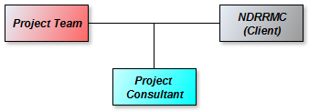

FIGURE 2, EXTERNAL INTERFACES

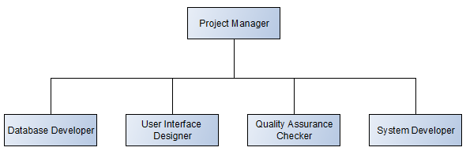
Internal Structure
FIGURE 2-1, INTERNAL STRUCTURE

Roles and Responsibilities
Name | Role/s | Responsibilities | Contact Details
Usec Ricardo Jalad | Client | Provides needed information to project team | ocda.ocd@gmail.com
Edmundo Casiño | Project Consultant | Provides expert advice in project team | totic@apc.edu.ph
Johanna Marisse Heramia | Project Manager, System Developer | Ensures the continuous communication with the client and lead developer of the system | johannaheramia@gmail.com
Jana Marie Gardon | Web Designer, Software Tester | Ensures a friendly user interface of the system and the system has quality | janamarie.gardon@gmail.com
Jose Lorenzo Tadeo | Database Designer | Ensures that the data has proper connections with other data | renzotadeo26@gmail.com
TABLE 2, ROLES AND RESPONSIBILITIES

Project Scope / Time / Cost Management Plan

Scope

Requirements Traceability Matrix
Requirement  No. | Name | Category | Source | Status
R1 | Laptop | Hardware | Project Charter
R3 | Project Libre | Software | Project Charter
R3 | PhpStorm | Software | Project Charter
R4 | XAMPP | Software | Project Charter
R5 | MySQL Workbench | Software | Project Charter
R5 | Yii2 framework | Software | Project Charter
R6 | Internet connectivity | Service | Project Charter
R7 | Hosting service | Service | Project Charter
TABLE 3, REQUIREMENTS TRACEABILITY MATRIX

Scope Statement
Project Summary and Justification:
Logistics System is created for the Office of Civil Defense of NDRRMC. This will be used to organize and store all information such as received and delivered supplies and transports, records of warehouses, volunteers, population, suppliers, reports and requests. This will benefit NDRRMC in both preparedness and response phases. The cost of the project is divided into personnel cost, hardware cost, software cost and service cost.
Project Characteristics and Requirements:
- Templates and Tools: AdminLTE template in Yii2 framework will be used for the design and integration of forms. Cassandra and MySql will be used for database.
- User submissions: The logistics system admin, regional admin, city / municipal mayor and external are the users of the system. All the users must have an account to access the system. The logistics admin is encouraged to sign up while the regional admin is to be signed up by the Logistics system admin. The mayor on the other hand will be added up by the regional admin. This process is for the security of the system as well as preventing unauthorized user to access the system.
- Information: All information on the system are real-time and updated by the different users according to their permission or access control. These includes the supplies, transports, requests, barangay and map of the Philippines. The supplies and transports are categorized.
- Requests for supplies and transports: The system will include a section for user to request supplies needed The request of two different users will only be between them.
- Map: The map provides the location of the warehouses, camps and barangays for the transports. The user can search for the items needed and its location. It also enables the user to search the nearest locations where they can find the supplies needed from their current location. Once the user clicks one of the location, the information like the warehouse name and the owner will be shown. Double click to view the list of supplies in the warehouse and one click to view the route.
- Security: The system must provide several levels of security. The system will ask first for the pin number to input before accessing the log in page to make sure that only the authorized person can use the system. The sign-up page for regional admin and mayor are disabled and only the logistics system admin can sign up the regional admin and the regional admin can sign up the mayor only. Only the information needed by the user will be shown or accessed.
- Reports: All items received and transported are automatically reported. The system has a page where all the reports will be viewed. Only users involved in the reports can view the information. This can also monitor if the transported vehicles arrived in its destination or if the supplies were delivered.

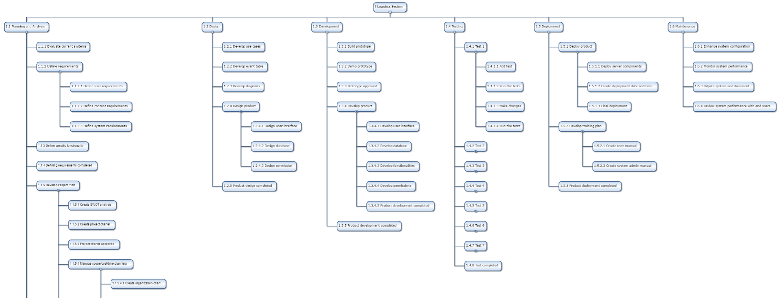
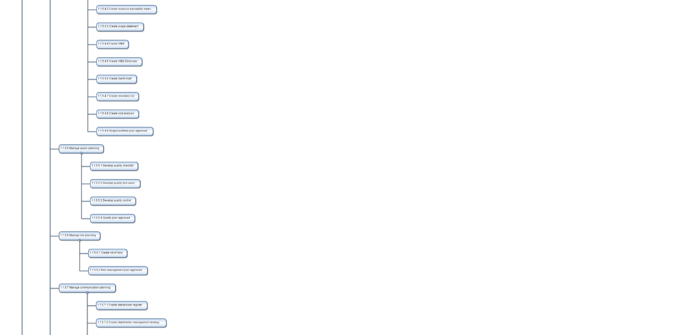
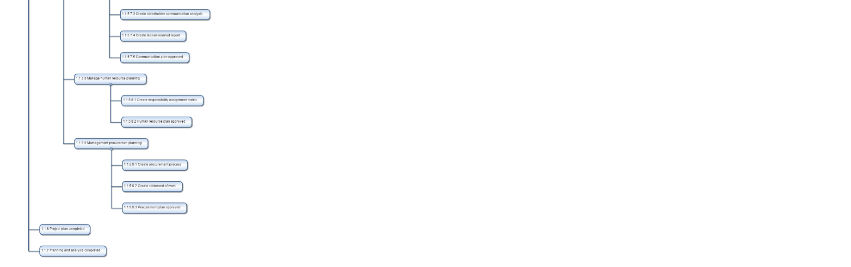
3.1.3 Work Breakdown Structure

Work Breakdown Structure Dictionary
Planning and Analysis
 | WBS Item Number | WBS Item Name | Description | Deliverable
1 | 1.1 | Planning and Analysis | Conceptualizing the proposed system.
2 | 1.1.1 | Evaluate current systems | Evaluate NDRRMC's current processes to be familiarize with their process and limit our proposed project scope to their scope.
3 | 1.1.2 | Define requirements | Identify the needed requirements for the NDRRMC's logistics process. | Requirements
4 | 1.1.2.1 | Define user requirements | Define the needs of the user for the system. | User requirements
5 | 1.1.2.2 | Define content requirements | Define what should be the content of the system. | Content requirements
6 | 1.1.2.3 | Define system requirements | Define functionalities of the system, and the software and hardware to be used. | System requirements
7 | 1.1.3 | Define specific functionality |  | Functionalities
8 | 1.1.4 | Defining requirements completed
9 | 1.1.5 | Develop project plan | Plan project working time, web design and its functionalities.
10 | 1.1.5.1 | Create SWOT analysis |  | SWOT Analysis
11 | 1.1.5.2 | Create project charter |  | Project Charter
12 | 1.1.5.3 | Project charter approved
12 | 1.1.5.4 | Manage scope/cost/time Planning
13 | 1.1.5.4.1 | Create organization chart | Collaboration with other project teams and the division of work among the group of Logistics system. | Organization Chart
14 | 1.1.5.4.2 | Create resource traceability Matrix |  | RTM
15 | 1.1.5.4.3 | Create scope statement | Defines the all tasks needed in creating product | Scope statement
16 | 1.1.5.4.4 | Create WBS | Create WBS to enumerate all process that were encountered and process that should be done. | Work Breakdown Structure
17 | 1.1.5.4.5 | Create WBS dictionary |  | WBS Dictionary
18 | 1.1.5.4.6 | Create Gantt chart | Create Gantt chart to evaluate the time to start and finish the project. | Gantt Chart
19 | 1.1.5.4.7 | Create milestone List | Create milestone plan to determine the duration of time the specific process should be done. | Milestone List
20 | 1.1.5.4.8 | Create cost analysis |  | Cost Analysis
21 | 1.1.5.4.9 | Scope/cost/time approved | Approved contents in the Scope/Cost/Time Management Plan | Scope/Cost/Time Plan
22 | 1.1.5.5 | Manage quality planning | Specify the quality standards relevant to the product
23 | 1.1.5.5.1 | Develop quality checklist |  | Quality Checklist
24 | 1.1.5.5.2 | Develop quality test cases
 | 1.1.5.5.3 | Develop quality control
25 | 1.1.5.5.4 | Quality plan approved | Approved contents in the Quality Management Plan | Quality Management Plan
26 | 1.1.5.6 | Manage risk planning | Specify the risk that may happen in the future, estimate  the impacts of those risk and how to response to that risk
27 | 1.1.5.6.1 | Create list of risks |  | Risk Register
28 | 1.1.5.6.2 | Risk management plan approved | Approved contents in the Risk Management Plan | Risk Management Plan
29 | 1.1.5.7 | Manage communication planning
30 | 1.1.5.7.1 | Create stakeholder register |  | Stakeholder register
31 | 1.1.5.7.2 | Create stakeholder management strategy |  | Stakeholder management strategy
32 | 1.1.5.7.3 | Create stakeholder communication analysis |  | stakeholder communication analysis
33 | 1.1.5.7.4 | Create expectation management matrix |  | Expectation Management Matrix
34 | 1.1.5.7.5 | Create Lessons-Learned Report
35 | 1.1.5.7.6 | Communication plan approved | Approved contents in the Communication Management Plan | Communication Management Plan
36 | 1.1.5.8 | Manage human resource planning
37 | 1.1.5.8.1 | Create responsibility assignment matrix |  | RAM
38 | 1.1.5.8.2 | Human resource plan approved | Approved contents in the Human Resource Management Plan | Human Resource Management Plan
39 | 1.1.5.9 | Manage Procurement Planning
40 | 1.1.5.9.1 | Create procurement process |  | Procurement process
41 | 1.1.5.9.2 | Create statement of work |  | Statement of work
42 | 1.1.5.9.3 | Procurement plan approved | Approved contents in the Procurement Management Plan | Procurement Management Plan
43 | 1.1.5.10 | Project plan completed |  | Project Plan
44 | 1.1.6 | Project and analysis Completed
TABLE 3-1, WBS DICTIONARY, PLANNING AND ANALYSIS

Design
 | WBS Item Number | WBS Item Name | Description | Deliverables
45 | 1.2 | Design
46 | 1.2.1 | Design use cases | Representation of a user's interaction with the system | Use case diagram
47 | 1.2.2 | Design event table | Representation of each scenario in the system | Event table
48 | 1.2.3 | Design diagrams | Representation of the flow of data | Data flow diagram
49 | 1.2.4 | Design product
50 | 1.2.4.1 | Design user interface | This activity designs the graphical user interface of the system | Sample user interface
51 | 1.2.4.2 | Design database | This activity designs the needed data of the system | Database design
52 | 1.2.4.3 | Design permission | Defines the role base access control of the users
53 | 1.2.5 | Product design completed | This is where the testing of design happens | Completed product design
TABLE 3-2, WBS DICTIONARY, DESIGN
Development

 | WBS Item Number | WBS Item Name | Description | Deliverables
55 | 1.3 | Development | The team starts to manage the development of the system.
56 | 1.3.1 | Build Prototype |  | Prototype
57 | 1.3.2 | Demo prototype | Demonstrate the system prototype.
58 | 1.3.3 | Prototype Approved | Coordinating with the other teams to have the same design of the system. | Prototype Design
59 | 1.3.4 | Develop Product | Started the development of the system.
60 | 1.3.4.1 | Develop user interface | Develop the user interface of the system. | User Interface
61 | 1.3.4.2 | Develop database | Develop the database of the system. | Database
 | 1.3.4.3 | Develop functionalities
62 | 1.3.4.4 | Develop permissions | Designate the roles and permission of the users.
63 | 1.3.4.5 | Product development completed | Completion of the system. | Logistic System
TABLE 3-3, WBS DICTIONARY, DEVELOPMENT
Testing
 | WBS Item Number | WBS Item Name | Description | Deliverables
55 | 1.4 | Testing | This activity is where the testing of the product occurs.
56 | 1.4.1 | Test 1 | This activity enumerates the steps for testing for test number 1. | Test 1
57 | 1.4.1.1 | Add test | This activity is the first step in testing. Gathering of test materials is done here.
58 | 1.4.1.2 | Run the tests | This activity is the second step in testing. Start of running tests in the material.
59 | 1.4.1.3 | Make changes | This activity is the third step in testing. Updates the material for improvement.
60 | 1.4.1.4 | Run the tests | This activity is the last step in testing. Start of running tests again in the updated material.
61 | 1.4.2 | Test 2 | This activity enumerates the steps for testing for test number 2. | Test 2
66 | 1.4.3 | Test 3 | This activity enumerates the steps for testing for test number 3.
71 | 1.4.4 | Test 4 | This activity enumerates the steps for testing for test number 4.
76 | 1.4.5 | Test 5 | This activity enumerates the steps for testing for test number 5.
81 | 1.4.6 | Test 6 | This activity enumerates the steps for testing for test number 6.
86 | 1.4.7 | Test 7 | This activity enumerates the steps for testing for test number 7.
91 | 1.4.8 | Test completed | completion of the testing the product. | Document Test Cases
TABLE 3-4, WBS DICTIONARY, TESTING

Deployment
 | WBS Item Number | WBS Item Name | Description | Deliverables
55 | 1.5 | Deployment | This activity covers the needed documents or materials before deployment.
56 | 1.5.1 | Deploy product | This activity defines the server components, deployment date and time, and final deployment.
57 | 1.5.1.1 | Deploy server components | This activity defines the needed components for a server to deploy.
58 | 1.5.1.2 | Create deployment date and time | This activity defines the date and time of deployment.
59 | 1.5.1.3 | Final deployment | This activity shows that it is ready for deployment.
60 | 1.5.2 | Develop training plan | This activity consists of manuals for staffs and end user. | Training Plan
61 | 1.5.2.1 | Create user manual | This activity defines the user manual of the system. | User Manual
62 | 1.5.2.2 | Create system admin manual | This activity defines the system admin manual of the system. | System Admin Manual
63 | 1.5.3 | Product deployment completed | This activity signifies that the product deployment is complete.
TABLE 3-5, WBS DICTIONARY, DEPLOYMENT
Maintenance
 | WBS Item Number | WBS Item Name | Description | Deliverables
55 | 1.6 | Deployment | This activity consists of enhance system configuration, system performance, system security, system and document update, and review system performance.
56 | 1.6.1 | Enhance system configuration | This activity defines the configurations that needed to be enhanced.
57 | 1.6.2 | Monitor system performance | This activity monitors the performance of the system.
58 | 1.6.3 | Update system and document | This activity updates the system and document after the responses of the end users. | Logistic System
59 | 1.6.4 | Review system performance with end users | This activity monitors the review of the system performance by the end users.
TABLE 3-6, WBS DICTIONARY, MAINTENANCE

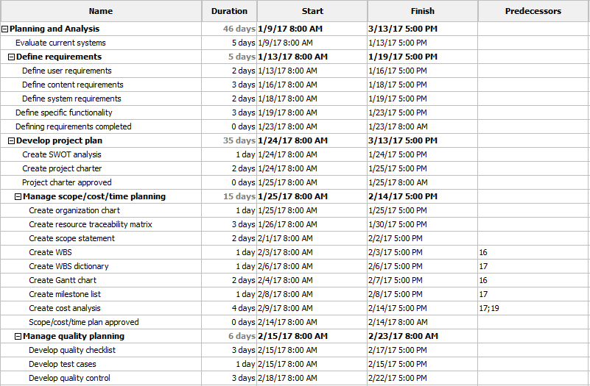
Gantt Chart

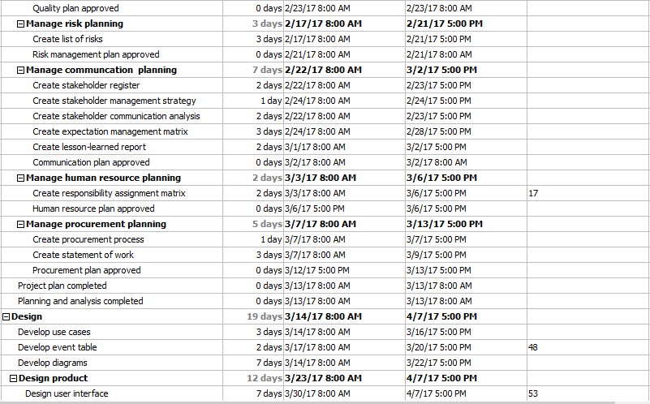

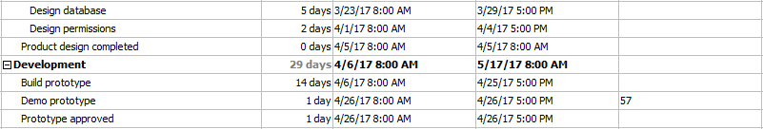

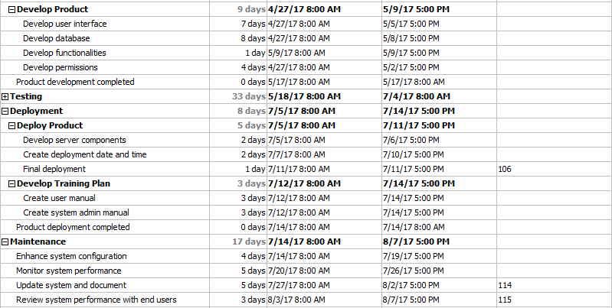

FIGURE 3, GANTT CHART

Resource Acquisition
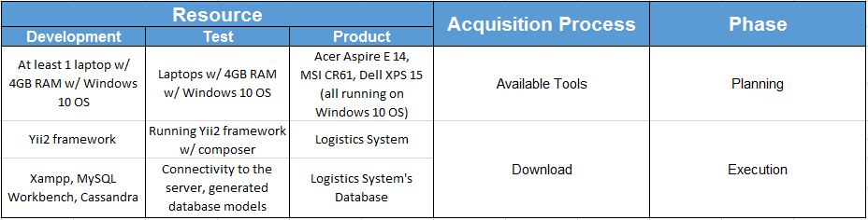

TABLE 3-7, RESOURCE ACQUISITION

Time

Activity List
Planning and Analysis
Activity ID No | Activity Name | Description of Work | Responsibility
1.1.1 | Evaluate current systems | This activity consists of analyzation of existing systems. | Johanna Marisse Heramia
1.1.2 | Define requirements | This activity defines the requirements of the project. | Johanna Marisse Heramia
1.1.2.1 | Define user requirements | This activity defines the requirements of a user. | Johanna Marisse Heramia
1.1.2.2 | Define content requirements | This activity defines the content requirements of the system. | Johanna Marisse Heramia
1.1.2.3 | Define system requirements | This activity defines the system requirements. | Johanna Marisse Heramia
1.1.3 | Define specific functionality | This activity defines the functionality of the system. | Johanna Marisse Heramia
1.1.4 | Defining requirements completed | This activity is where all requirements are completed and approved.
1.1.5 | Develop project plan | This activity consists of different plans for the project to succeed. | Johanna Marisse Heramia
1.1.5.1 | Create SWOT analysis | This activity defines the strength, weaknesses, opportunity, and threat of the project. | Johanna Marisse Heramia
1.1.5.2 | Create project charter | This activity defines the overview of the project. | Johanna Marisse Heramia
1.1.5.3 | Project charter approved | This activity is where the overview of the project is approved.
1.1.5.4 | Manage scope/cost/time Planning | This activity consists of different plans such as Scope, Cost, and Time Management Plan.
1.1.5.4.1 | Create organizational chart | This activity defines the hierarchy of the project team and stakeholders. | Jose Lorenzo Tadeo
1.1.5.4.2 | Create resource traceability matrix | This activity defines the needed resources for the project to succeed. | Johanna Marisse Heramia
1.1.5.4.3 | Create scope statement | This activity defines the scope statement of the project. | Jana Marie Gardon
1.1.5.4.4 | Create WBS | This activity defines the activities needed for the project to succeed. | Johanna Marisse Heramia
1.1.5.4.5 | Create WBS dictionary | This activity defines the detailed version of WBS. | Jose Lorenzo Tadeo
1.1.5.4.6 | Create Gantt chart | This activity measures the start date and finished date of an activity. | Johanna Marisse Heramia
1.1.5.4.7 | Create milestone list | This activity defines the milestones of each phase. | Jana Marie Gardon
1.1.5.4.8 | Create cost analysis | This activity defines the cost estimate of the project. | Johanna Marisse Heramia
1.1.5.4.9 | Scope/cost/time plan approved | This activity is where the plans for Scope, Cost, and Time are approved.
1.1.5.5 | Manage quality plan | This activity consists of quality checklist, quality control, etc.
1.1.5.5.1 | Develop quality checklist | This activity defines the checklist of the project. | Jose Lorenzo Tadeo
1.1.5.5.2 | Develop quality test cases | This activity test the product if it has quality or not. | Jana Marie Gardon
1.1.5.5.3 | Develop quality control | This activity defines on how to control the quality of the project. | Johanna Marisse Heramia
1.1.5.5.4 | Quality plan approved | This activity is where the plan for quality is approved.
1.1.5.6 | Manage risk planning | This activity defines on how to manage the risks.
1.1.5.6.1 | Create list of risks | This activity defines the top 5 risk of the project. | Jose Lorenzo Tadeo
1.1.5.6.2 | Risk management plan approved | This activity is where the plan for risk management is approved.
1.1.5.7 | Management communication planning | This activity consists of stakeholder register, communication analysis, etc.
1.1.5.7.1 | Create stakeholder register | This activity defines the stakeholders of the project. | Johanna Marisse Heramia
1.1.5.7.2 | Create stakeholder management strategy | This activity defines the risk of each project team members. | Johanna Marisse Heramia
1.1.5.7.3 | Create stakeholder communication analysis | This activity defines on how to communicate with the project team and stakeholders. | Jana Marie Gardon
1.1.5.7.4 | Create expectation management matrix | This activity defines the expectations of each stakeholders. | Jose Lorenzo Tadeo
1.1.5.7.5 | Create lesson-learned report | This activity is done by all project members to give their insight about their performance. | Johanna Marisse Heramia
1.1.5.7.6 | Communication plan approved | This activity is where the plan for communication management is approved.
1.1.5.8 | Management Human Resource Planning | This activity consists of RAM
1.1.5.8.1 | Create responsibility assignment matrix | This activity defines the roles of each project member in a activity. | Jose Lorenzo Tadeo
1.1.5.8.2 | Human resource plan approved | This activity is where the plan for Human Resource is approved.
1.1.5.9 | Manage procurement planning | This activity defines the statement of work and make or buy analysis.
1.1.5.9.1 | Create procurement process
1.1.5.9.2 | Create statement of work | This activity defines the activities, deliverables, and timelines. | Jose Lorenzo Tadeo
1.1.5.9.3 | Procurement plan approved | This activity is where the plan for procurement is approved.
1.1.5.10 | Project plan completed | This activity is where the project plan is completed.
1.1.7 | Planning and analysis completed | This activity is where the analysis phase is completed.
TABLE 3-8, ACTIVITY LIST, PLANNING AND ANALYSIS

Design
Activity ID No | Activity Name | Description of Work | Responsibility
1.2.1 | Develop use cases | This activity consists of all possible scenario that a user may encounter. It is also a detailed version of event table. | Jana Marie Gardon
1.2.2 | Develop event table | This activity consists of sequence events that a user may perform. It is also the basis of all diagrams. | Jana Marie Gardon
1.2.3 | Develop diagrams | This activity consists of possible flows of the data, connection of the system to users, etc. CFD, DFD, etc. are included in this activity. | Jose Lorenzo Tadeo
1.2.4 | Design product | This activity consists of design in UI, database, permission, etc. | Jana Marie Gardon
1.2.4.1 | Design user interface | This activity integrates the ideas of different developers resulting in the interface of the system. | Jana Marie Gardon
1.2.4.2 | Design database | This activity connects all data that are needed in the system. | Jose Lorenzo Tadeo
1.2.4.3 | Design permission | This activity summarizes the permissions of each users of the system. | Johanna Marisse Heramia
1.2.5 | Product design completed | This activity is the finalized design of the product.
TABLE 3-9, ACTIVITY LIST, DESIGN
Development
Activity ID No | Activity Name | Description of Work | Responsibility
1.3.1 | Build prototype | This activity is where the developer’s start's building a prototype. | Johanna Marisse Heramia
1.3.2 | Demo prototype | This activity is where the developers demonstrates the prototype. | Johanna Marisse Heramia
1.3.3 | Prototype approved | This activity is where the prototype is approved and ready for development.
1.3.4 | Develop product | This activity consists of developing the finalized version of UI, database, permission, etc. | Johanna Marisse Heramia
1.3.4.1 | Develop user interface | This activity is where the UI of the system is being develop. | Jana Marie Gardon
1.3.4.2 | Develop database | This activity is where the Database of the system is being develop. | Jose Lorenzo Tadeo
1.3.4.3 | Develop functionalities | This activity is where the functionalities of the product is being develop. | Johanna Marisse Heramia
1.3.4.4 | Develop permission | This activity is where the Permission of each user is being develop. | Johanna Marisse Heramia
1.3.5 | Product development completed | This activity means that the development of the product is completed.
TABLE 3-10, ACTIVITY LIST, DEVELOPMENT

Deployment
Activity ID No | Activity Name | Description of Work | Responsibility
1.5.1 | Deploy product | This activity defines the requirement to deploy the product. | Johanna Marisse Heramia
1.5.1.1 | Deploy server components | This activity defines the server components needed for deployment. | Johanna Marisse Heramia
1.5.1.2 | Create deployment date and time | This activity defines the date and time of implementing the product. | Johanna Marisse Heramia
1.5.1.3 | Final deployment | This activity means that the product is ready for deployment. | Johanna Marisse Heramia
1.5.2 | Develop training plan | This activity is where the manuals are being created | Johanna Marisse Heramia
1.5.2.1 | Create user manual | This activity gives the users a manual of the product. | Johanna Marisse Heramia
1.5.2.2 | Create system admin manual | This activity gives the administrator a manual for configuring the product. | Johanna Marisse Heramia
1.5.3 | Product deployment completed | This activity means that the deployment of the product is completed.
TABLE 3-11, ACTIVITY LIST, DEPLOYMENT

Maintenance
Activity ID No | Activity Name | Description of Work | Responsibility
1.6.1 | Enhance system configuration | This activity enhances the systems configuration by aligning it to the latest programs. | Johanna Marisse Heramia
1.6.2 | Monitor system performance | This activity monitor the system's performance if it has bugs or slowing down. | Johanna Marisse Heramia
1.6.3 | Update system and document | This activity is where the update of system and document are done. | Johanna Marisse Heramia
1.6.4 | Review system performance with end users | This activity checks the reviews of the end users about the new update. | Johanna Marisse Heramia
TABLE 3-12, ACTIVITY LIST, MAINTENANCE

Milestone List
- Defining Requirements Completed
- Product Design Completed
- Product Development Completed
- Deployment Completed
- Transition Plan Completed
- Training Plan Completed

Schedule Control
Changes in schedule is unavoidable, so monitoring schedule and tracking changes in schedule are part of the project management processes for Logistics System to make sure that project gets finished on schedule.
Project manager will use Gantt chart to monitor changes in the project’s schedule. This is a chart where in the activities, time, start and end date, predecessors, etc., are being shown. This will give the project manager are graphical overview of all the tasks.

Cost

Budget Allocation
Cost Item - Personnel Cost | January | February | March | April | May | June | July | August | Total
Project Manager | 26,057 | 38,400 | 38,400 | 38,400 | 38,400 | 38,400 | 38,400 | 10,971 | 267,428
UI Designer | - | - | 11,752 | 3,357 | - | - | - | - | 15,109
System Developer | - | - | - | 24,006 | 30,553 | 30,553 | 30,553 | 30,553 | 146,218
Database Developer | - | - | 13,404 | 26,809 | 16,276 | - | - | - | 56,489
Software Tester | - | - | - | - | 11,316 | 31,685 | 3,394 | - | 46,395
Personnel Cost per Month | 26,057 | 38,400 | 63,556 | 92,572 | 96,545 | 100,638 | 72,347 | 41,524 | 531,639
Cost Item - Technology Cost | January | February | March | April | May | June | July | August | Total
Laptop Hardware
Basic Laptop | 90,999 |  |  |  |  |  |  |  | 90,999
Software - Management Tool
Project Libre | -
Software - Development Tool
PhpStorm for PHP Developer | - | - | - | 651.49 | 829.17 | 829.17 | 829.17 | 621.88 | 3760.88
XAMPP | -
MySQL Workbench | -
Software - Automated Testing Tool
Yii2 Framework | -
Internet & Services
Internet Connectivity (PLDT) | - | - | - | 2,799 | 3,499 | 3,499 | 3,499 | 749.79 | 14,045.79
Hosting service (.com) | - | - | - | - | - |  | 504.00 | 11.82 | 515.82
Technology Costs per Month | 95,439 | 4,494 | 4,494 | 4,494 | 4,494 | 4,494 | 4,494 | 4,340 | 109,321.49
WBS costs per Month | 121,496 | 42,894 | 68,050 | 97,066 | 101,039 | 105,132 | 76,841 | 45,864 | 640,716.49
Contingency Cost |  |  |  |  |  |  |  |  | 19,221.50
Management Cost |  |  |  |  |  |  |  |  | 32,035.82
Overall Total |  |  |  |  |  |  |  |  | 691,973.81

Personnel Cost | Daily Rate | Monthly Rate
Project Manager | PHP 1,371.43 | PHP 38,400.00
UI Designer | PHP 839.43 | PHP 23,504.00
System Developer | PHP 1,091.18 | PHP 30,553.00
Database Developer | PHP 957.43 | PHP 26,808.00
Software Tester | PHP 1,131.61 | PHP 31,685.00
Technology Costs | Daily Rate | Monthly Rate
Basic Laptop | - | - | PHP 90,999.00
Project Libre | - | -
PhpStorm for PHP Developers | PHP 29.61 | PHP 829.17 | Free 30-day trial
XAMPP | - | -
MySQL Workbench | - | -
Yii2 Framework | - | -
Internet Connectivity (PLDT) | PHP 124.96 | PHP 3,499.00 | 15 Mbps
Domain (.com) | PHP 18.00 | PHP 504.00

TABLE 3-13, BUDGET ALLOCATION

Budget Control
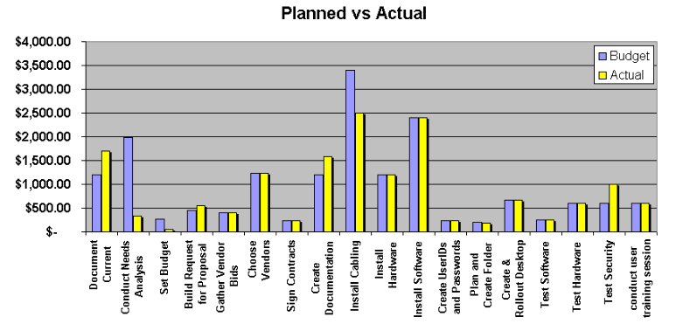
For the project to be a success, the budget allotted to the project must be monitored and controlled throughout the duration. The Project Manager is responsible for monitoring and controlling the budget. An example of budget control is a chart of planned vs actual that can be seen in the chart below, like in the following figure:

FIGURE 4, BUDGET CONTROL
From the example, we cannot get the exact value of each activity, but Project Managers can base from this chart because it shows the best case and worst-case scenario in each activity.

Project Quality Management Plan

Quality Assurance
Process Area | Metric | How to collect | Who will collect?
Software Development | Project Completed | Review all process and deliverables | Project Manager
Software Development | Budget Cost | Get the planned cost for the project | Project Manager
Software Development | Actual Cost | Determine the budget spent | Project Manager
Software Development | Planned Value | BAC*EPC | Project Manager
Software Development | Earned Value | BAC*APC | Project Manager
Software Development | Cost Performance Index | EV/AC | Project Manager
Software Development | Schedule Performance Index | PV/AC | Project Manager
Software Development | Estimate To Complete | (BAC-EV)/CPI | Project Manager
Software Development | Estimate at Complete | BAC/CPI | Project Manager
TABLE 4, QUALITY ASSURANCE

Quality Checklist
Item No. |  | Yes | No | N.A.* | Comments
1 | Functionality
1.1 | Forms
1.1.1 | Acceptance of valid input
1.1.2 | Optional versus mandatory fields
1.1.3 | Input longer than field allows
1.1.4 | Is Command Button can be used for Hyperlinks and Continue Links?
1.1.5 | Are all the data inside dropdown menu are arranged in chronological order?
1.1.6 | Does a scrollbar appear if required?
1.2 | Data verification and validation
1.2.1 | Is the Privacy Policy clearly defined and available for user access?
2 | Application specific Functional Requirements
2.1 | Data integration
2.1.1 | Check the maximum field lengths to ensure that there are no truncated characters?
2.1.2 | If numeric fields accept negative values can these be stored correctly on the database and does it make sense for the field to accept negative numbers?
2.2 | Date field checks
2.2.1 | Assure that leap years are validated correctly & do not cause errors/miscalculations.
2.2.2 | Assure that Feb. 28, 29, 30 are validated correctly & do not cause errors/ miscalculations.
2.3 | Numeric fields
2.3.1 | Assure that lowest and highest values are handled correctly.
2.3.2 | Assure that numeric fields with a blank value are processed or reported as an error.
2.3.3 | 3 Assure that both + and - values are correctly processed.
2.3.4 | Assure that upper and lower values in ranges are handled correctly.
2.4 | Alphanumeric field checks
2.4.1 | Include lowest and highest values.
2.4.2 | Include invalid characters & symbols.
2.4.3 | Include valid characters
3 | Interface and error handling
3.1 | Server interface
3.1.1 | Verify that communication is done correctly, web server-application server, application server-database server and vice versa.
3.1.2 | Compatibility of server software, hardware, network connections
3.2 | External interface
3.2.1 | Have all supported browsers been tested?
3.2.2 | Have all error conditions related to external interfaces been tested when external application is unavailable or server inaccessible?
3.3 | Internal interface
3.3.1 | If the site uses plug-ins, can the site still be used without them?
3.3.2 | Can all linked documents be supported or opened on all platforms (i.e. can Microsoft Word be opened on Solaris)?
3.3.3 | Are failures handled if there are errors in download?
3.4 | Internal interface
3.4.1 | If the system does crash, are the re-start and recovery mechanisms efficient and reliable?
3.4.2 | If we leave the site in the middle of a task does it cancel?
3.4.3 | If we lose our Internet connection does the transaction cancel?
3.4.4 | Does our solution handle browser crashes?
3.4.5 | Does our solution handle network failures between website and application servers?
4 | Compatibility
4.1 | Browsers
4.1.1 | Is the HTML version being used compatible with appropriate browser versions?
4.1.2 | Do images display correctly with browsers under test?
4.1.3 | Verify the fonts are usable on any of the browsers
4.2 | Connection speed
4.3.1 | Does the site load quickly enough in the viewer's browser?

Item No. | Subject | Yes | No | N.A.* | Comments
1 | Functionality
1.1 | User interface
1.1.1 | Are the field backgrounds and field prompts the correct color?
1.1.2 | Are the screen and field colors adjusted correctly for non-editable mode?
1.1.4 | Does the site use (approximately) standard link colors?
1.1.5 | Are all the buttons in standard format and size?
1.2 | Content
1.2.1 | All fonts to be the same
1.2.2 | Are all the screen prompts specified in the correct screen font?
1.2.4 | Is all text properly aligned?
1.3 | Images
1.3.1 | Are all graphics properly aligned?
1.3.2 | Are graphics being used the most efficient use of file size?
1.3.3 | Does text wrap properly around pictures/graphics?
1.3.4 | Is it visually consistent even without graphics?
1.4 | Instructions
1.4.1 | Is all the error message text spelt correctly on this screen?
1.4.2 | Is all the micro-help text (e.g. tool tip) spelt correctly on this screen?
1.4.3 | Progress messages on load of tabbed (active screens) screens
1.5 | Navigation
1.5.1 | Can all screens accessible via buttons on this screen be accessed correctly?
1.5.3 | Is there a link to home on every single page?
1.5.4 | When an error message occurs does the focus return to the field in error when the user cancels it?
1.6 | Usability
1.6.1 | Are all the field prompts spelt correctly?
1.6.2 | Are fonts too large or too small to read?
1.6.5 | Can the typical user run the system without frustration?
1.6.6 | Does the site convey a clear sense of its intended audience?
1.6.7 | Does user can login Member Area with both username/email ID?
1.6.8 | Does the site look good on different screen resolution?
1.6.9 | Is all terminology understandable for all of the site’s intended users?

Item No. | Subject | Yes | No | N.A.* | Comments
1 | Management of users
1.1 | Does user have roles and been identified and assigned an appropriate level of authority?
1.2 | Does user have level of access control in the system?
1.3 | Does user can access the system everywhere
1.4 | Can user add any user?
1.5 | Can user change their level of access control?
1.6 | Can user change their personal information?
1.7 | Can user signup anywhere?
1.8 | Will user use their username when logging in to their account?
1.9 | Will there be any report regarding with the records of user?

Item No. | Subject | Yes | No | N.A.* | Comments
1 | Map
1.1 | Can all user view all the places included in the system?
1.2 | Can all the places included in the system be seen in map?
1.3 | Can all nearby places be automatically seen in the map?
1.4 | Can user add places (e.g. warehouse) directly to the map?
1.5 | Does map contain map of the Philippines only?
1.6 | Can the user add places directly to the map?
1.7 | Can map locate the user's current direction?

Item No. | Subject | Yes | No | N.A.* | Comments
1 | Management of volunteer
1.1 | Can the user report all supplies needed to inventory system?
1.1.1 | Does the inventory system can view the list of report from the Logistics admin?
1.2 | Is the user allowed to report transport shipments such as arrived and deployed transport?
1.2.1 | Can the regional admin view the report from the mayor?
1.3 | Does the mayor has an access to the report of transport shipments from the regional?
1.3.1 | Do the mayor report all delivered transports?
1.4 | Can the regional admin reports supplies shipments such as arrived and distributed supplies?
1.5 | Is there report for the supplies expiration?
1.5.1 | Does all user have an expiration report?
TABLE 4.1, QUALITY CHECKLIST

Quality Control
The quality control primarily focuses on the Logistics System project and the acceptable standards and performance that was set by the International Organization for Standardization particularly ISO/IEC/IEEE 29119:2015. The project team will determine the acceptable standards and will be reviewed by the project manager. Many standards will be based on ISO/IEC/IEEE 29119:2015, however the project team anticipated that there will be several unique quality standards in the development which will require new quality standards. Functional testing will be performed by the project team.
Function Test Coverage = FE/FT
FE – is the number of test requirements that are covered by test cases that were executed against the software
FT – is the total number of test requirements
The project team will perform the Functional testing to indicate the percentage of completion of the product. Should there be any changes while performing the test, it shall be discussed on the “Run the tests” at the end of each test. The Project Manager will schedule a regular meeting to review the findings or possible findings from the quality team.

Project Human Resource Management Plan

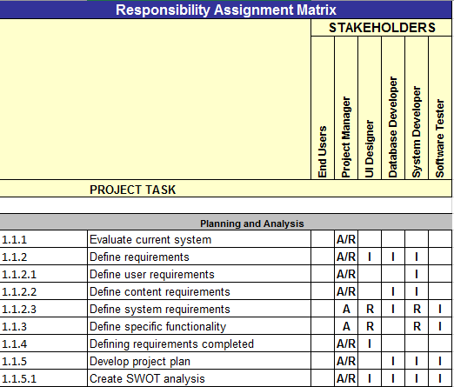
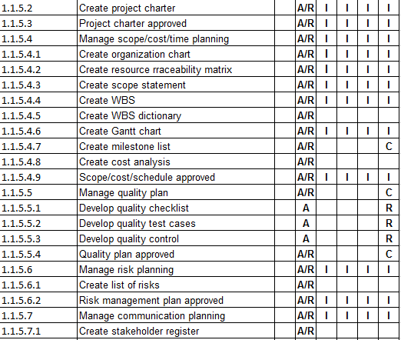
Responsibility Assignment Matrix

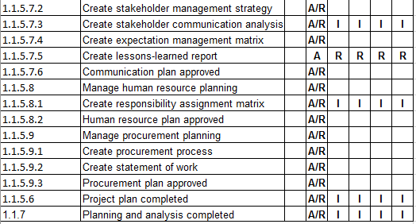

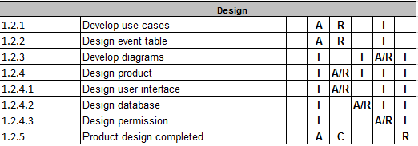

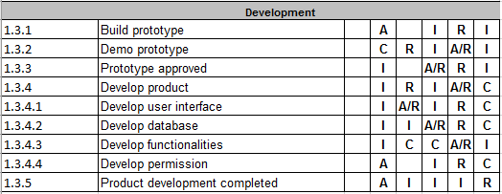

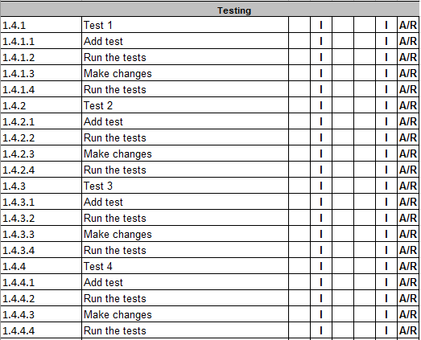

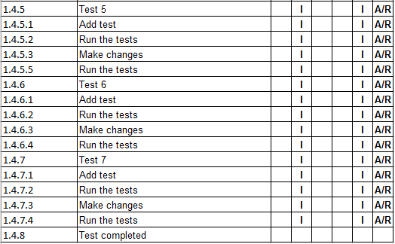

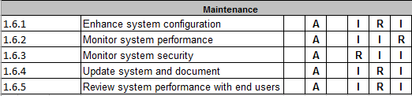

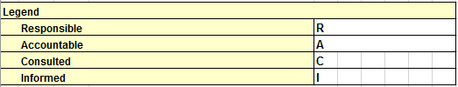
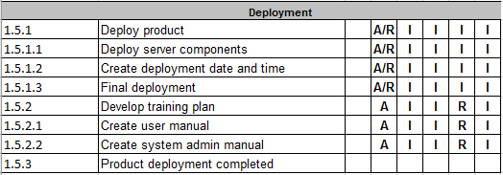

TABLE 5, RESPONSIBILITY ASSIGNMENT MATRIX

Project Communication Management Plan

Stakeholder Register

TABLE 6, STAKEHOLDER REGISTER

Stakeholder Management Strategy
TABLE 6-1, STAKEHOLDER MANAGEMENT STRATEGY

Stakeholder Communication Analysis
Stakeholders | Document Name | Document Format | Contact Person | Due
Customer Management | System  Project Plan  User Manual | Hard copy  Email  Meeting | Usec Ricardo B. Jalad,  Susan Quiambao | July 11, 2017
Internal Management | Monthly status and progress report  Project plan | Hard copy  Email  Meeting | Johanna Heramia,  Jana Marie Gardon,  Jose Lorenzo Tadeo | Weekly  March 13, 2017
TABLE 6-2, STAKEHOLDER COMMUNICATION ANALYSIS

Project Risk Management Plan

Top 5 Risks
TABLE 7, TOP 5 RISKS
Category | Probability of Occurrence | Impact | Risk | Mitigation Approaches
Scope problem | Low | High | Frequent Scope Change | Ensure that in start of project, the project team already determined and concluded the scope to prevent unnecessary changes.
Project Team member’s participation | Medium | High | Project Team members assigned modules are not being develop. | Ensure that the team member is committed in developing the module assigned to him/her. Everyone should follow a strict schedule and the assigned task for each member is in line with its skills and goal. Project member must have the determination to complete the project so that no matter how complicated the tasks are, they will still do it.
Technical Risk | Medium | High | Product is complex to implement | Decide a product software implementation method to make detailed process in implementing a product
Schedule slippage | High | High | Delayed Schedule | Make plan that arranges the schedule as early as possible for each task that are needed to be completed and in case of delay, there must be back up plan for schedule activities.
Monitoring tasks | Medium | High | Lack of Monitoring | Make a weekly status report and let everyone in the team know what should be completed and what task should be completed next. Ensure everyone are on the same page.

Risk flowchart
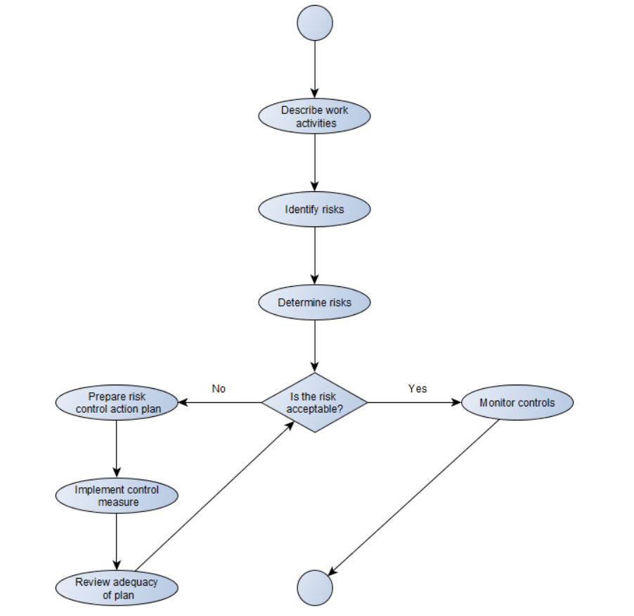
FIGURE 7, RISK FLOWCHART

Project Procurement Management Plan

Procurement Process
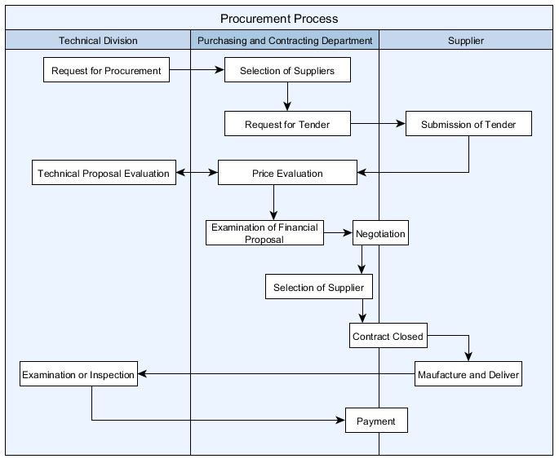

FIGURE 8, PROCUREMENT PROCESS

The above flowchart represents the flow in the procurement process. In the start, the project manager (PM) needs a physical server for deployment. The PM then submits a document containing the specifications of the needed server to the Purchasing department to look for potential suppliers. After reviewing the document, the Purchasing department will look for suppliers that can provide that server. After choosing 3 potential suppliers, the Purchasing department must send an invitation to that suppliers to submit a bid for the server. When the suppliers received the invitation, they will analyze the document coming from the PM to meet the specification needed to submit a tender that will be admitted for full evaluation, with the best possible chances for success. After submitting the tender, the Purchasing department will evaluate the price given by the suppliers. The PM will also submit a proposal for evaluation. After evaluating the price given by the suppliers and PM, the Purchasing department will perform an examination to the financial proposal. After examining the financial proposal, negotiation will be done between the Purchasing department and the 3 suppliers. After the negotiation, the Purchasing department will choose between the 3 suppliers to close a contract with. After the selection between the 3 suppliers, only one supplier is left and the Purchasing department must perform a closeout plan to bind the supplier to give a server to the PM. After the closeout plan, the supplier must manufacture the server and deliver it to the PM and the PM must perform an examination and a thorough inspection of the server. After the examination and thorough inspection, the PM will give the payment for the server to Purchasing department, and the Purchasing department will pay the supplier.

